YEAR 11 INTEGRATED SCIENCE GENERAL
2022 TASK 2: CELLS AND BODY SYSTEMS TEST

Name: | Date: | Teacher:
MARK:
/40
This task is worth 5% of your overall mark.

- In the space below, draw a labelled diagram of an animal cell and a plant cell (4 marks)

- Describe the function of the following organelles found in cells: (2 marks)
Nucleus:
_____________________________________________________________________________________________________________________________________________________________________________________________________________________________________________________________________
Mitochondria:
_____________________________________________________________________________________________________________________________________________________________________________________________________________________________________________________________________

- List and describe the function of two other organelles which are not found in both types of cells
(2 marks)
Organelle 1:
_____________________________________________________________________________________________________________________________________________________________________________________________________________________________________________________________________
Organelle 2:
_____________________________________________________________________________________________________________________________________________________________________________________________________________________________________________________________________
- List the eight life processes/characteristics that all living things have in common (4 marks)
1. | 5.
2. | 6.
3. | 7.
4. | 8.

- The cell membrane is described as a fluid mosaic model. Explain what this means. (2 marks)
____________________________________________________________________________________________________________________________________________________________________________________________________________________________________________________________________________________________________________________________________________________________
- Compare and contrast the similarities and differences between diffusion, passive transport, facilitated transport and active transport across the cell membrane. (5 marks)
_____________________________________________________________________________________________________________________________________________________________________________________________________________________________________________________________________________________________________________________________________________________________________________________________________________________________________________________________________________________________________________________________________________________________________________________________________________________________________________________________________________________________________________________________________________________________________________________________________________________________________________________________________________________________________________________________________________________________________________________________
- Explain the relationship between cells, tissue, organs, and systems and give an example of each organisational level (5 marks)
_____________________________________________________________________________________________________________________________________________________________________________________________________________________________________________________________________________________________________________________________________________________________________________________________________________________________________________________________________________________________________________________________________________________________________________________________________________________________________________________________________________________________________________________________________________________________________________________________________________________________________________________________________________________________________________________________________________________________________________________________
- Explain the role of the digestive system (3 marks)
____________________________________________________________________________________________________________________________________________________________________________________________________________________________________________________________________________________________________________________________________________________________
- Label the 5 main parts of the human digestive system (5 marks)
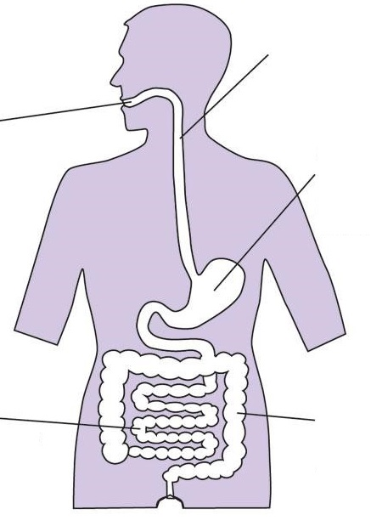

- Write an extended response which outlines the process of digestion as you eat your dinner.
(8 marks)
________________________________________________________________________________________________________________________________________________________________________________________________________________________________________________________________________________________________________________________________________________________________________________________________________________________________________________________________________________________________________________________________________________________________________________________________________________________________________________________________________________________________________________________________________________________________________________________________________________________________________________________________________________________________________________________________________________________________________________________________________________________________________________________________________________________________________________________________________________________________________________________________________________________________________________________________________________________________________________________________________________________________________________________________________________________________________________________________________________________________________________________________________________________________________________________________________________________________________________________________________________________________________________________________________________________________________________________________________________________________________________________________________________________________________________________________________________________________________________________________________________________________________________________________________________________________________________________________________________________________________________________________________________________________________________________________________________________________________________________________________________________________________________________________________________________________________________________________________________________________________________________________________________________________________________________________________________________________________________________________________________________________________________________________________________________________________________________________________________________________________________________________________________________________

